## **Daily Scrum Chats**

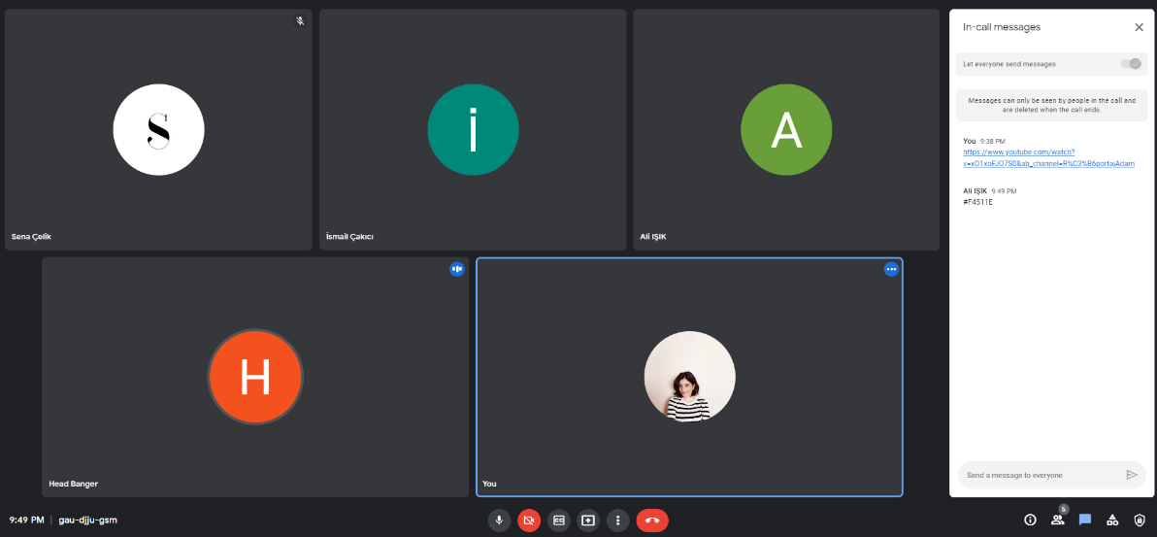

Şekil - 23.05.2022 Daily Scrum_Sprint_3

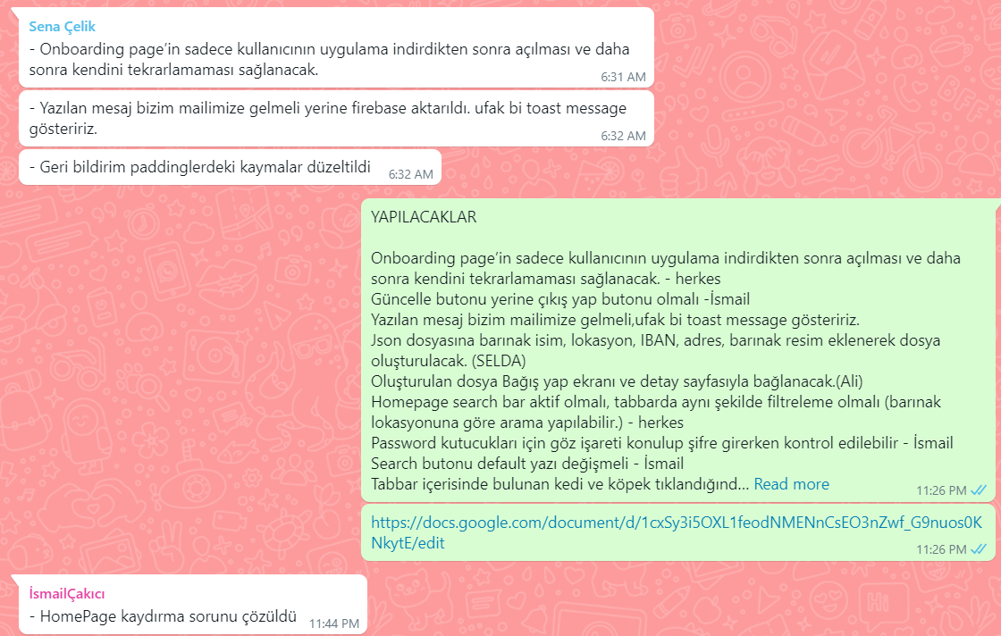

Şekil - 24.05.2022 Daily Scrum_Sprint_3

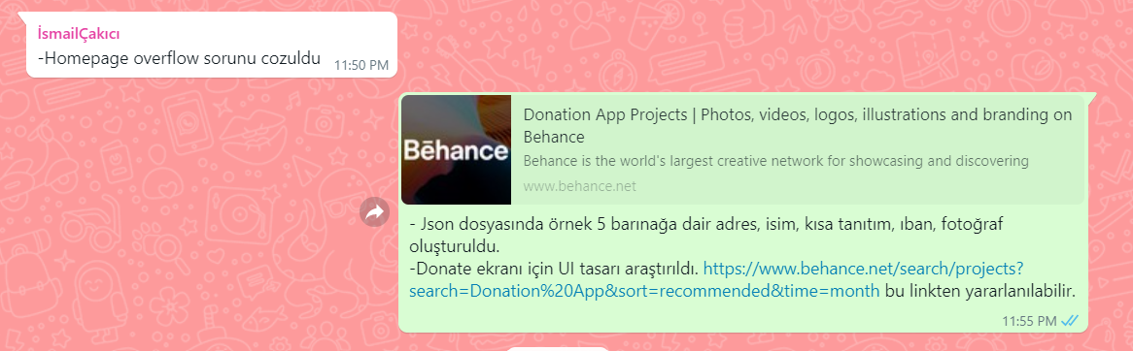

Şekil - 25.05.2022 Daily Scrum_Sprint_3

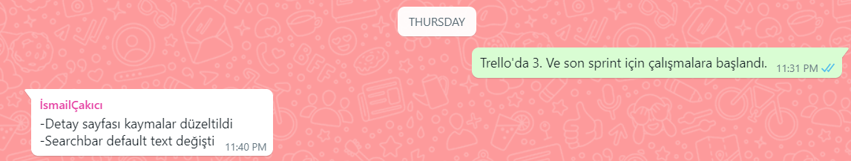

Şekil - 26.05.2022 Daily Scrum_Sprint_3

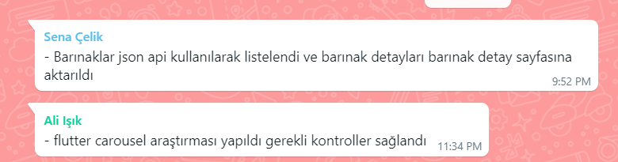

Şekil - 27.05.2022 Daily Scrum_Sprint_3

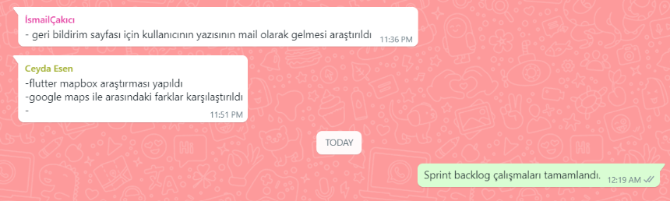

Şekil - 28.05.2022 Daily Scrum_Sprint_3

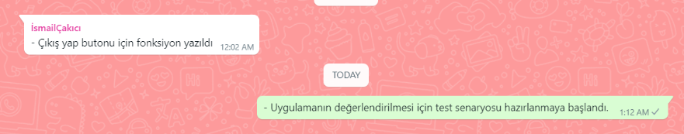

Şekil - 29.05.2022 Daily Scrum_Sprint_3

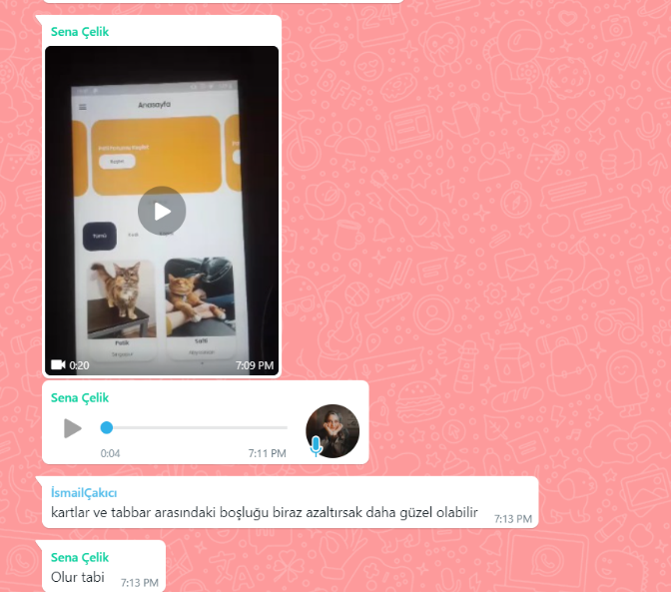  
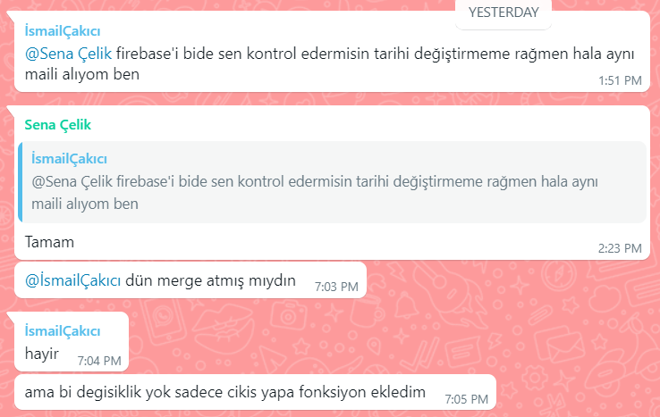

Şekil - 30.05.2022 Daily Scrum_Sprint_3

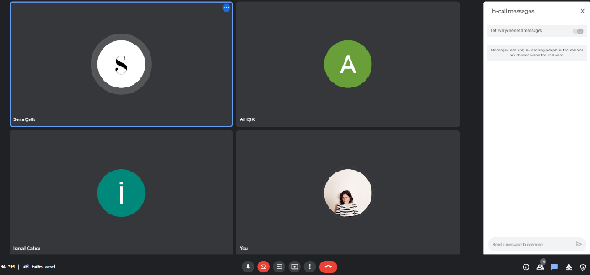

Şekil - 31.05.2022 Daily Scrum_Sprint_3

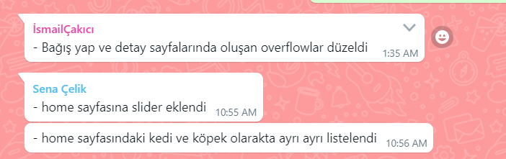

Şekil - 01.06.2022 Daily Scrum_Sprint_3

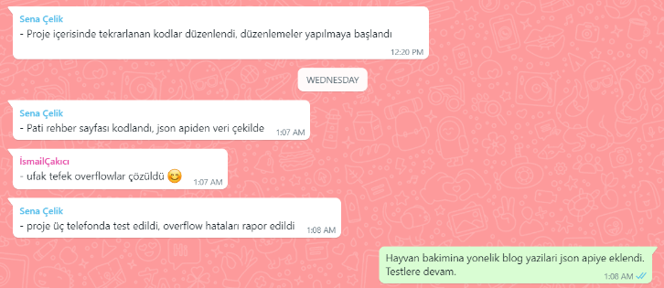

Şekil - 02.06.2022 Daily Scrum_Sprint_3

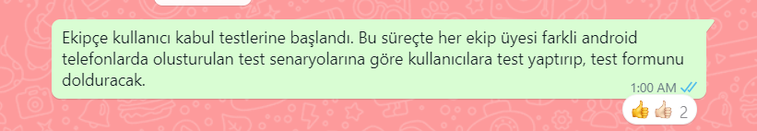

Şekil - 03.06.2022 Daily Scrum_Sprint_3

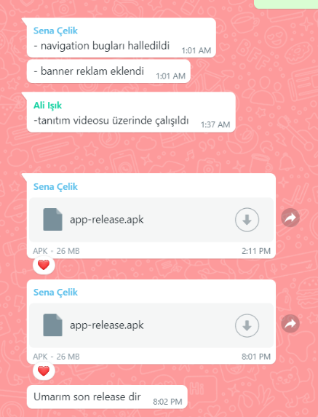

Şekil - 04.06.2022 Daily Scrum_Sprint_3

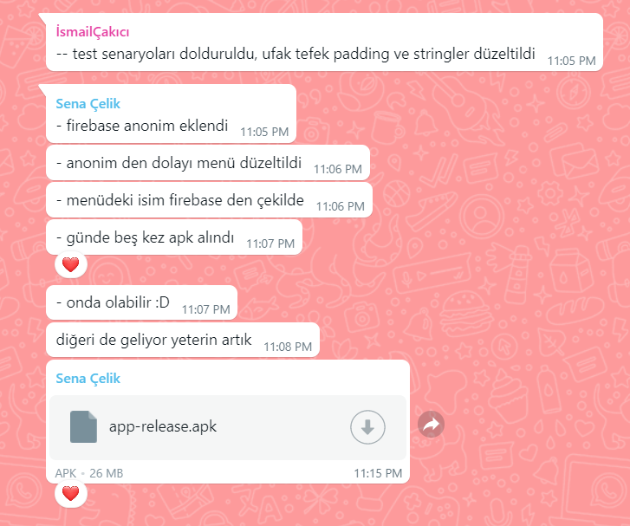

Şekil - 05.06.2022 Daily Scrum_Sprint_3